VISVESVARAYA TECHNOLOGICAL UNIVERSITY JNANA SANGAMA, BELAGAVI – 590018


A Synopsis on

“Online Examination System with Proctoring and Secure Authentication”

Submitted for the Major Project Work-Phase 1 of the Academic Year 2025-26

Submitted by

Sudeep Kagi 1NT23EC157

Vinayak Sanmani 1NT23EC185

Prasanna M B 1NT23EC109

Under the Guidance of

Dr. Manjula B M

Professor

Department of Electronics and Communication Engineering

Department of Electronics and Communication Engineering

An Autonomous Institution Affiliated to Visvesvaraya Technological University, Yelahanka, Bangalore- 560064, Karnataka, INDIA

AY 2025-2026



DEPARTMENT OF ELECTRONICS AND COMMUNICATION ENGINEERING

Certificate
This is to certify that the Phase-1 project work entitled “Online Examination System with Proctoring and Secure Authentication” has been carried out by Sudeep Kagi (1NT23EC157), Vinayak Sanmani (1NT23EC185), and Prasanna M B (1NT23EC109), bonafide students of Nitte Meenakshi Institute of Technology, in partial fulfillment of the requirements for the award of the degree of Bachelor of Engineering in the Department of Electronics and Communication Engineering under Visvesvaraya Technological University, Belagavi, during the academic year 2025–2026.
The project report has been examined and approved as it meets the academic requirements specified under the autonomous scheme of Nitte Meenakshi Institute of Technology for the said degree.

Signature of the Guide Signature of the HoD Signature of the Principal

Dr. Manjula B M
Professor Dept. of ECE, NMIT

Dr. Parameshachari B D
HoD
Dept. of ECE, NMIT
Dr. H C Nagaraj Principal NMIT

External Viva-Voce

Name of Examiners Signature with Date

- …………………………….. …………………………..

- …………………………….. …………………………..

Acknowledgement
The successful execution of our project has been a significant milestone, and we take this opportunity to express our heartfelt gratitude to all those who have supported and guided us throughout this journey. Whatever we have achieved is the result of their encouragement and help, and we remain deeply thankful to each one of them.

We also convey our deep appreciation to Dr. Parameshachari B D, Professor and HoD, Department of Electronics and Communication Engineering, for his constant encouragement, valuable guidance, and for fostering a vibrant learning environment. We extend our heartfelt thanks to our project guide, Dr./Prof. [Name], [Designation], Department of Electronics and Communication Engineering for his/her unwavering support, timely feedback, and insightful mentorship throughout the project. We are also indebted to our parents for their unconditional love, support, and encouragement throughout our academic journey at Nitte Meenakshi Institute of Technology, Bengaluru. Finally, we would like to express our appreciation to all those—named and unnamed—who contributed in any way to our learning and success.

Sudeep Kagi ((1NT23EC157) Vinayak Sanmani (1NT23EC185) Prasanna M B (1NT23EC109)

Place: NMIT, Bengaluru

Academic Year: 2025–2026 Declaration by Students
We, the undersigned students Student1 (USN), Student2 (USN), Student3 (USN) and Student4 (USN) hereby declare that we are fully aware of the project conduction procedures and evaluation rubrics as prescribed by the department. We understand that the project work will be evaluated through continuous assessment across the defined phases.

Name of the Student | Signature
Sudeep Kagi
Vinayak Sanmani
Prasanna M B

Confirmation by Guide

I , Dr.Manjula B M , hereby declare that I shall guide the above-mentioned students in the project entitled "Online Examination System with Proctoring and Secure Authentication"and will ensure that the project work is carried out under my supervision and submitted as per the academic requirements for the academic year 2025–2026.

Signature of the Guide

Table of Contents
- Introduction 7
- Literature Review 10
- System Analysis 12
- System Design 15
- Implementation 20
- Testing 23
- Results and Discussion 26
- Conclusion and Future Work 27
- References 28
- Appendix 29

INTRODUCTION

Background
The global education landscape has undergone a remarkable transformation over the past decade, driven by the rapid adoption of digital technologies. The COVID-19 pandemic further accelerated this shift, compelling educational institutions worldwide to transition from traditional, in-person assessment methodologies to online examination systems. While this transformation has enhanced accessibility and flexibility, it has simultaneously introduced significant challenges related to academic integrity, identity verification, and real-time monitoring of candidates.

Conventional online examination platforms predominantly rely on password-based authentication, which is susceptible to credential sharing and impersonation. Furthermore, the absence of robust proctoring mechanisms enables candidates to engage in malpractice with relative ease — including consulting unauthorized materials, switching browser tabs, or using proxy candidates. The demand for a system that combines the convenience of online assessment with the integrity assurances of a supervised, in-person examination has therefore become paramount.

This project addresses these limitations by developing a comprehensive Online Examination System with Proctoring and Secure Authentication. The system integrates real-time webcam- based facial recognition, secure multi-factor authentication, browser activity monitoring, and automated violation logging — creating an examination environment that is both accessible and highly secure.

Problem Statement
Existing online examination systems suffer from three core deficiencies:
- Authentication Weakness: Most platforms rely solely on username-password combinations. This single-factor mechanism is highly vulnerable to impersonation, credential sharing, and brute-force attacks. There is no continuous verification that the candidate who logged in is the same person completing the examination.
- Absence of Real-Time Proctoring: Without active monitoring, candidates can easily access external resources, communicate with others, or replace themselves with a proxy. Passive proctoring (recording and reviewing later) is time-consuming and often impractical at scale.
- Lack of Tamper-Proof Mechanisms: Many systems do not prevent tab-switching, copy- paste operations, or window changes during an examination, making it trivial for candidates to seek external assistance.
The proposed system is motivated by the need for a cost-effective, lightweight, and practically deployable solution that addresses all three deficiencies simultaneously, ensuring the credibility and fairness of online assessments.

Project Objectives
The primary objectives of this project are:
- To design and develop a web-based online examination system that supports secure and efficient conduct of examinations across multiple user roles (Admin, Examiner, Candidate).
- To implement robust multi-factor authentication mechanisms that verify candidate identity before and continuously during the examination, thereby preventing unauthorized access and impersonation.
- To integrate real-time proctoring features — including webcam-based facial detection, eye-gaze monitoring, and activity tracking — for detecting and logging malpractice incidents during examinations.
- To ensure examination integrity and transparency through automated violation handling mechanisms, including warnings, forced termination, and comprehensive audit trails.
- To develop a scalable, platform-independent system deployable on standard institutional hardware with minimal infrastructure investment.

Scope of the Project
The scope of this project encompasses the following:
- Development of a full-stack web application with role-based access control (Admin, Examiner, Candidate).
- Implementation of a secure login system with password hashing and session token management.
- Webcam-based facial recognition for identity verification at login and periodic re- verification during the exam.
- Real-time monitoring of candidate behaviour including tab-switch detection, multiple-face alerts, and absence detection.
- Dynamic question paper generation, time-bound examination sessions, and automated result computation.
- A comprehensive admin dashboard for managing examinations, candidates, and reviewing proctoring logs.
The system is limited to objective-type (MCQ) and short-answer examinations in the current phase. Subjective/essay-type evaluation with AI grading is proposed as a future enhancement.

Organization of the Report
The remainder of this report is organized as follows:
- Chapter 2 presents a review of existing literature and related work in online examination systems and proctoring technologies.
- Chapter 3 covers system analysis including feasibility study, functional and non- functional requirements, and use case descriptions.

- Chapter 4 details the system design including architecture, block diagrams, DFD, ER diagram, module design, and database schema.
- Chapter 5 describes the implementation approach, technology stack, and module-wise development.
- Chapter 6 presents the testing strategy and results across unit, integration, system, and user acceptance testing.
- Chapter 7 discusses results and system performance metrics.
- Chapter 8 concludes the report and outlines directions for future work.

LITERATURE REVIEW

Existing Systems and Related Work

Traditional Online Examination Systems
Early online examination systems such as Moodle Quiz and Google Forms transitioned paper- based tests to digital formats, offering benefits such as instant result computation and question randomization. However, these platforms were not designed with security or proctoring as core features. Studies by Karim et al. (2014) highlighted that the lack of candidate monitoring in basic LMS-based examinations led to a significant increase in academic dishonesty. The reliance on honour-based systems proved insufficient for high-stakes assessments.

Proctored Examination Platforms
Commercial platforms such as ProctorU, Respondus Monitor, and ExamSoft introduced remote proctoring by recording the candidate's screen, webcam feed, and audio. Ullah et al. (2021) evaluated these platforms and found that while they are effective, they impose significant privacy concerns, require high-bandwidth internet connections, and are economically prohibitive for many institutions in developing countries. Additionally, their AI-based flagging systems have been reported to exhibit racial and lighting-bias in face detection algorithms.

Facial Recognition in Authentication
The application of facial recognition for candidate authentication in examinations has been explored extensively. Ibrahim et al. (2020) proposed a system using OpenCV's Haar cascade classifiers for face detection, achieving approximately 89% accuracy under controlled lighting conditions. More recent work by Chen and Zhao (2022) utilizing deep learning models (FaceNet, MTCNN) demonstrated recognition accuracies exceeding 97%, even under varying illumination and partial occlusion. This project draws upon these methodologies, implementing a lightweight face detection pipeline suitable for standard institutional hardware.

Browser Integrity and Tab-Switch Detection
Bharadwaj et al. (2019) investigated the use of the HTML5 Page Visibility API and JavaScript event listeners for detecting browser-focus changes during online tests. Their study found that such mechanisms, when combined with candidate warnings and automatic logging, reduced tab- switching incidents by over 70%. This approach is adopted in the proposed system as a non- intrusive yet effective proctoring layer.

Multi-Factor Authentication in Academic Platforms
Singh and Arora (2021) conducted a comprehensive review of multi-factor authentication (MFA) methods in educational technology platforms, evaluating combinations of biometric, OTP-based, and token-based methods. They concluded that combining facial biometrics with secure session tokens provides the optimal balance between security and usability for examination environments. Their framework informed the authentication architecture adopted in this project.

Automated Proctoring with AI
Atoum et al. (2017) proposed a comprehensive automated proctoring framework using deep neural networks for face detection, head-pose estimation, and eye-gaze tracking. While their system achieved high detection accuracy, its computational requirements were significant. Subsequent lightweight implementations for resource-constrained environments were explored by Ngo et al. (2020), who demonstrated viable proctoring using MediaPipe and TensorFlow.js — approaches that directly influenced the client-side proctoring implementation in this project.

Comparative Analysis
Table 2.1 presents a structured comparison of existing online examination systems based on key security and functional parameters.

System / Platform | MFA | Real-Time Proctoring | Face Recognition | Tab- Lock | Open- Source | Cost
Moodle Quiz | ✗ | ✗ | ✗ | ✗ | ✓ | Free
Google Forms | ✗ | ✗ | ✗ | ✗ | ✓ | Free
ProctorU | ✓ | ✓ | ✓ | ✓ | ✗ | High
Respondus Monitor | Partial | ✓ | ✓ | ✓ | ✗ | High
ExamSoft | ✓ | ✓ | Partial | ✓ | ✗ | High
Proposed System | ✓ | ✓ | ✓ | ✓ | ✓ | Low
Table 2.1 – Comparative Analysis of Existing Online Examination Systems

Research Gap Identified
The survey of existing literature reveals a clear research gap: while commercial proctoring platforms offer comprehensive monitoring, they are prohibitively expensive and raise significant privacy concerns. Open-source platforms offer accessibility but lack security features. No existing open-source solution successfully integrates all three critical components — secure multi-factor authentication, real-time AI-powered proctoring, and tamper-proof examination delivery — in a single, cost-effective, and deployable package suitable for small-to-medium educational institutions.

The proposed system directly addresses this gap by delivering an integrated, open-source- compatible, web-based examination platform that combines robust authentication, real-time proctoring, and examination management under a single unified architecture.

SYSTEM ANALYSIS

Feasibility Study

Technical Feasibility
The proposed system is technically feasible. All required technologies — Python, Flask/Django, HTML5, CSS3, JavaScript, OpenCV/MediaPipe for facial recognition, and MySQL — are mature, well-documented, and freely available. The hardware requirements (Intel i3 processor, 4 GB RAM, webcam, stable internet) are standard in modern academic institutions, making deployment straightforward without specialized infrastructure.

Economic Feasibility
The system is developed entirely using open-source frameworks and libraries, eliminating licensing costs. Deployment can be achieved on existing institutional servers or low-cost cloud platforms. Operational costs are minimal, comprising server hosting and maintenance. Compared to commercial proctoring solutions (ProctorU charges per examination session), the proposed system offers a dramatically more cost-effective alternative for institutions with frequent examination schedules.

Operational Feasibility
The system is designed with usability at its core. The intuitive web interface requires no specialized training for candidates or examiners. Admin functionalities are logically organized with clear workflows. The system operates within standard web browsers without requiring candidates to install specialized software, reducing friction and support overhead.

Functional Requirements

FR# | Module | Description
FR01 | User Registration | Admin registers candidates with basic profile details and uploads a reference face photograph for biometric baseline.
FR02 | Secure Login | Candidates log in using credentials; system verifies identity via facial recognition before granting exam access.
FR03 | Exam Scheduling | Admin/Examiner creates and schedules examinations with configurable duration, subject, and question count.
FR04 | Question Management | Examiner adds, edits, and manages question banks with MCQ and short-answer types; supports random selection.
FR05 | Examination Delivery | System serves questions in randomized order, enforces time limits, and locks the browser window during examination.

FR06 | Real-Time Proctoring | Webcam feed is continuously monitored for face presence; alerts generated for multiple faces, absence, or gaze deviation.
FR07 | Tab-Switch Detection | JavaScript event listeners detect focus changes; logs violations and issues progressive warnings to the candidate.
FR08 | Auto Evaluation | MCQ responses are auto-evaluated at submission; scores computed and stored with timestamped answer logs.
FR09 | Violation Logging | All proctoring events (face absent, tab switch, multiple faces) are timestamped and stored in the proctoring log.
FR10 | Result Generation | Examiner/Admin can view, filter, and export examination results; candidates can view their own result post-exam.
FR11 | Admin Dashboard | Centralized dashboard for managing users, exams, questions, and reviewing proctoring reports.
Table 3.1 – Functional Requirements

Non-Functional Requirements

Attribute | Requirement
Performance | Page load time < 2 seconds; facial detection latency < 500ms; system  supports ≥ 100 concurrent users.
Security | All passwords hashed using bcrypt; sessions managed with secure JWT tokens; HTTPS enforced.
Reliability | System uptime ≥ 99.5%; data auto-saved every 60 seconds to prevent loss during disconnection.
Scalability | Modular architecture allows addition of new modules; database supports horizontal scaling.
Usability | Interface operable without training; WCAG 2.1 AA accessibility compliance; mobile-responsive design.
Maintainability | Code follows MVC architectural pattern; comprehensive inline documentation; modular component structure.
Compatibility | Supports Chrome, Firefox, and Edge (latest versions); Windows and Linux operating systems.
Table 3.2 – Non-Functional Requirements

Use Case Description
The following table presents the detailed use case description for the primary user interaction: Candidate Login and Authentication.

Field | Description
Use Case ID | UC-01
Use Case Name | Candidate Login and Identity Authentication
Actor | Candidate, Authentication Module, Facial Recognition Engine
Pre-condition | Candidate is registered in the system; reference photo is stored; exam is scheduled and active.
Main Flow | 1. Candidate navigates to login page. 2. Enters registered username and password. 3. System validates credentials against the database. 4. On valid credentials, webcam is activated. 5. Facial Recognition Engine captures live frame. 6. System compares live frame with stored reference photo. 7. On match (similarity ≥ threshold), candidate is granted access to the examination dashboard.
Alternate Flow | 3a. Invalid credentials → error message displayed; login denied. 6a. Face not detected → candidate prompted to adjust position; 3 retries allowed. 6b. Face mismatch → authentication denied; incident logged; admin notified.
Post-condition | Candidate is authenticated and directed to the examination interface; session token issued.
Exception | If webcam is unavailable, the system falls back to a manual ID verification alert sent to the admin.
Table 3.3 – Use Case Description: Candidate Login & Authentication

SYSTEM DESIGN

System Architecture Overview
The system follows a three-tier client-server architecture comprising a Presentation Layer (frontend), an Application/Business Logic Layer (backend), and a Data Layer (database). Communication between layers is facilitated via RESTful APIs, ensuring loose coupling and enabling future scalability. The architecture is designed to support simultaneous multi-user access while maintaining data isolation and security between examination sessions.

Block Diagram
Figure 4.1 presents the overall system architecture as a block diagram, illustrating the interaction between the three primary user roles (Admin, Examiner, Candidate) and the core system modules.

┌─────────────────────────────────────────────────────────────────────────┐
│ ONLINE EXAMINATION SYSTEM │
│ with Proctoring & Secure Authentication │
└──────────────┬──────────────────────┬──────────────────────┬───────────┘
│ │ │
┌──────▼──────┐ ┌──────▼──────┐ ┌──────▼──────┐
│ ADMIN │ │ EXAMINER │ │ CANDIDATE │
│ PORTAL │ │ PORTAL │ │ PORTAL │
└──────┬──────┘ └──────┬──────┘ └──────┬──────┘
│ │ │
┌──────▼──────────────────────▼──────────────────────▼──────┐
│ PRESENTATION LAYER (Frontend) │
│ HTML5 │ CSS3 │ JavaScript │
└─────────────────────────────┬──────────────────────────────┘
│ REST API
┌─────────────────────────────▼──────────────────────────────┐
│ APPLICATION LAYER (Backend) │
│ ┌──────────┐ ┌──────────┐ ┌──────────┐ ┌───────────────┐│
│ │ AUTH │ │ EXAM │ │PROCTORING│ │ RESULT ││
│ │ MODULE │ │ ENGINE │ │ MODULE │ │ MODULE ││
│ └──────────┘ └──────────┘ └──────────┘ └───────────────┘│
│ Python (Flask / Django) │ OpenCV / MediaPipe │
└─────────────────────────────┬──────────────────────────────┘
│
┌─────────────────────────────▼──────────────────────────────┐
│ DATA LAYER (Database) │
│ Users │ Examinations │ Questions │ Attempts │ Proc.Logs │
│ MySQL / PostgreSQL │
└─────────────────────────────────────────────────────────────┘

Figure 4.1 – Overall System Architecture Block Diagram

Data Flow Diagram (DFD)

Level 0 – Context Diagram
The context diagram (Figure 4.2) illustrates the overall boundary of the system and its interactions with the three primary external entities.

┌─────────┐  │ ADMIN │─────  └─────────┘ | ┌─────────────┐  Manage Users/Exams/Results ────────▶│ │  │ │
┌──────────┐ | │ ONLINE │  │ EXAMINATION │
│EXAMINER │──── | Create Questions / View Reports ───▶│ SYSTEM │
└──────────┘ | │ │
┌──────────┐ | │ │  │ │
│CANDIDATE │◀─── | Exam Access / Results / Alerts ────▶│ │
└──────────┘ | └─────────────┘

Figure 4.2 – Data Flow Diagram Level 0 (Context Diagram)

Level 1 – Expanded DFD
Figure 4.3 expands the system boundary into its four major processing subsystems.
CANDIDATE
─────────
Credentials ──▶ [1.0 Authentication] ──▶ Session Token
ADMIN
─────
│
Face Frame ──▶ [2.0 Proctoring] ──▶ Violation Logs ─────────▶
Dashboard
Answers ──▶ [3.0 Exam Engine] ──▶ Score Record ─────────▶ Reports
│ │
▼ │
EXAMINER ────▶ [4.0 Question Bank] ──▶ Question Store ──────────▶│
│
▼
┌──────────────┐
│ DATABASE │
│ (MySQL/PG) │
└──────────────┘
Figure 4.3 – Data Flow Diagram Level 1 (Expanded)

Entity-Relationship (ER) Diagram
Figure 4.4 presents the ER diagram showing the key entities and relationships in the database.
┌──────────┐
registers
┌──────────────┐ contains
┌──────────┐
│ USERS │──────────────────────▶│ EXAMINATIONS
│──────────────▶│QUESTIONS │
│──────────│ │──────────────│
│──────────│

│ | user_id | │ |  | │ exam_id  │ | │ |  | │ | ques_id
│ | name | │ |  | │ title  │ | │ |  | │ | exam_id
 | │ email |  | │ | │ subject question │ |  | │ |  | │
│ | password | │ |  | │ duration  │ | │ |  | │ | options
│ role |  | │ |  | │ start_time │  │ |  |  | │ answer
│ photo |  | │ |  | │ created_by │  │ |  |  | │ marks
 |  | └────┬─────┘ |  | └──────┬───────┘  └──────────┘
 |  | │ attempts |  | │ generates

▼ |  |  | ▼
┌────────────────┐ |  |  | ┌─────────────────────┐
│ EXAM_ATTEMPTS │ |  |  | │ PROCTORING_LOGS │
│────────────────│ |  |  | │─────────────────────│
│ | attempt_id | │ | │ | log_id | │
│ | user_id | │ | │ | attempt_id | │
│ | exam_id | │ | │ | violation_type | │
│ | score | │ | │ | timestamp | │
│ | start_time | │ | │ | screenshot_path | │
│ | end_time | │ | │ | severity | │

Figure 4.4 – Entity-Relationship (ER) Diagram
│ status
│ └─────────────────────┘
└────────────────┘

Module Design

Authentication Module
The Authentication Module is responsible for verifying the identity of all users. It operates in two phases: (a) Credential Verification — where the entered password is compared against the bcrypt hash stored in the database; and (b) Biometric Verification — where the candidate's live webcam capture is compared against the stored reference photograph using a face recognition pipeline. A JWT-based session token is issued upon successful dual-factor authentication, which is validated on every subsequent API request.

CANDIDATE ──▶ Enter Credentials ──▶ [Validate Password Hash]
│
┌────────▼─────────┐
│ Password Match? │
└─────┬──────┬─────┘ YES│ │NO
▼ ▼
[Activate Webcam] [Login Denied]
│
[Capture Face Frame]
│
[Compare with Reference Photo]
│ │
MATCH ▼ ▼ MISMATCH
[Issue JWT Token] [Auth Denied + Log]
│
[Access Exam Dashboard]
Figure 4.5 – Authentication Module Flow

Proctoring Module
The Proctoring Module operates in real-time throughout the examination session. It interfaces with the candidate's webcam through browser APIs and processes video frames at regular intervals (every 3 seconds) to detect face presence, count faces in frame, and estimate gaze direction. Simultaneously, JavaScript event listeners monitor for browser-focus loss events. All detected violations are classified by severity (Low/Medium/High), timestamped, and stored in the Proctoring Logs table.

EXAM SESSION ACTIVE
│
┌──────▼───────────────────────────────────────────────┐
│ PROCTORING MONITOR (Every 3 sec) │
└──────┬───────────────┬────────────────┬──────────────┘
│ │
┌─────▼──────┐ ┌─────▼──────┐
│Face Present│ │Face Count │
│ Detection │ │ (1 or >1) │
└─────┬──────┘ └─────┬──────┘
│ │
│
┌──────▼──────┐
│Tab/Window │
│Focus Check │
└──────┬──────┘
│
┌──────▼───────────────▼────────────────▼──────────────┐
│ VIOLATION HANDLER │
│ None ──▶ Continue │ Low ──▶ Warning │
│ Medium ──▶ Alert + Log │ High ──▶ Terminate + Log │
└───────────────────────────────────────────────────────┘
│
[Save to Proctoring_Logs DB]
Figure 4.6 – Proctoring Module Flow

Examination Engine
The Examination Engine manages the lifecycle of a single examination attempt. It randomly selects a configured number of questions from the question bank for the scheduled exam, presents them sequentially with navigation controls, enforces the time limit with an auto-submit mechanism, and processes submitted answers for automated evaluation.

[Candidate Authenticated] ──▶ [Load Exam Config]
│
[Randomly Select N Questions]
│
[Start Timer & Serve Question 1]
│
┌─────────▼──────────┐
│ Navigation Loop │
│ Q1 → Q2 → … → QN │
└─────────┬──────────┘
│
[Submit / Timer Expired]
│
[Evaluate MCQ Answers]
│
[Store Score + Answers]
│
[Display Result Summary]
Figure 4.7 – Examination Engine Flow

VPN-Based Network Security Module

The VPN (Virtual Private Network) Security Module establishes a mandatory encrypted network layer between the candidate's device and the examination server, ensuring that all examination traffic is transmitted through a secure, authenticated tunnel. This module complements the application-level security mechanisms (JWT authentication, bcrypt hashing) by enforcing network-level access control,

preventing unauthorized external access to the examination portal.

Operational Flow

Before accessing the examination portal, the candidate must establish a VPN connection to the institutional server. The system verifies the candidate's VPN session before granting access to the login page. If a valid VPN connection is not detected, the portal redirects the user with an appropriate error message.

Key Functions of the VPN Module
- Encrypted Tunneling — All data exchanged between the candidate's browser and the examination server is encrypted using industry-standard protocols, preventing man-in-the-middle (MITM) attacks and packet sniffing during the examination session.
- IP Whitelisting — The examination server is configured to accept connections only from the VPN gateway's IP range. Direct access attempts from non-VPN IP addresses are rejected at the firewall level, ensuring that the portal is not publicly accessible.
- Session Binding — The VPN session is bound to the examination session. If the VPN connection drops during an examination, the proctoring module detects the network interruption, pauses the session, and logs a violation event, preventing candidates from bypassing the VPN requirement mid-exam.
- Traffic Isolation — Examination traffic is isolated within the VPN tunnel, preventing candidates from accessing external resources (websites, shared drives, communication tools) through the same network interface during the examination.
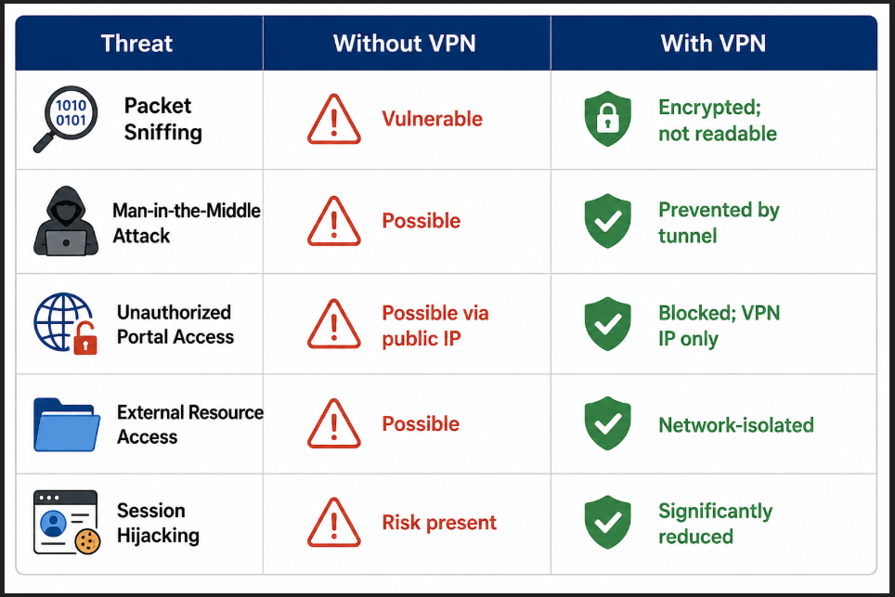

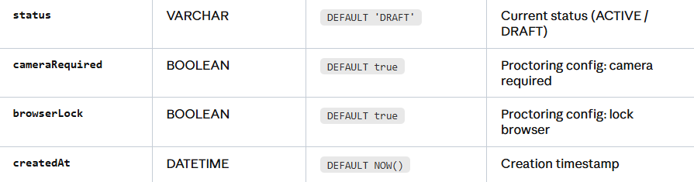
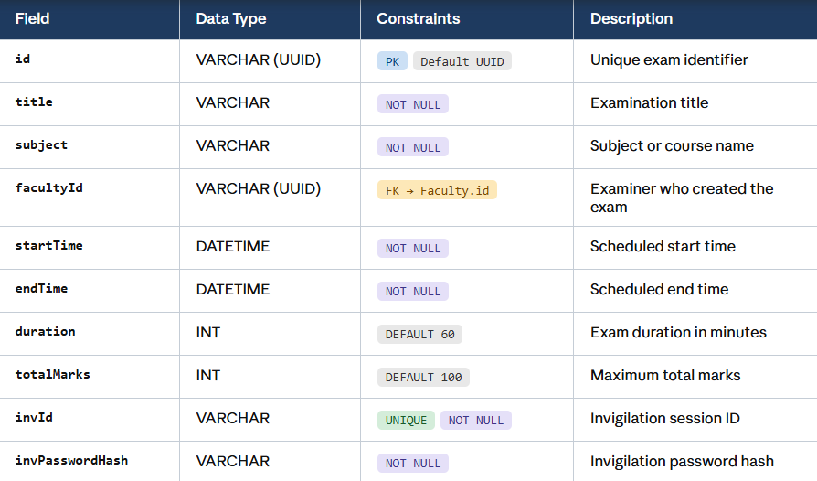
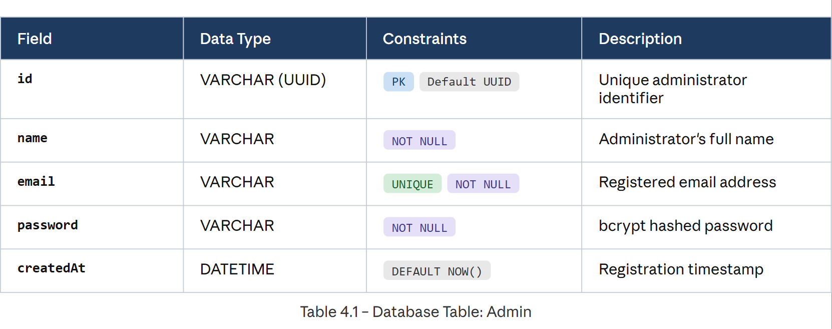
Database Design

IMPLEMENTATION

Technology Stack
The system is implemented using a carefully selected technology stack that balances performance, security, and deployment simplicity. Table 5.1 summarizes the technologies used across all layers.

Layer | Technology | Justification
Frontend | HTML5, CSS3, JavaScript (ES6+),  React JS | Responsive, cross-browser compatible UI; no framework overhead.
Backend | Python 3.10 Flask / Django, Node JS | Rapid development, rich ecosystem, strong ML library support.
Face Recognition | OpenCV, face_recognition (dlib), MediaPipe | Lightweight, real-time face detection on standard hardware.
Database | MySQL 8.0 / PostgreSQL 14 | ACID compliance, robust relational schema support.
Authentication | JWT (PyJWT), bcrypt | Stateless session management; industry-standard password hashing.
API | RESTful JSON API | Decoupled frontend-backend; easy to extend and test.
Browser Monitoring | JavaScript (Page Visibility API, DevTools Detection) | No server-side overhead; real-time client event detection.
Documentation | MS Word, MS PowerPoint | Standard academic submission format.
OS / Deployment | Windows / Linux; Apache / Nginx | Cross-platform support; standard institutional infrastructure.
Table 5.1 – Technology Stack Summary

Module-Wise Implementation
The system is implemented following an iterative development methodology, with each module developed, tested, and integrated independently before system-level integration.

Authentication Module Implementation
The authentication module implements a two-phase security mechanism:

Phase 1: Credential Authentication
User passwords are hashed using bcrypt with a cost factor of 12 during registration. During login, the entered password is verified against the stored hash using bcrypt's constant-time comparison function, preventing timing attacks. Upon successful credential verification, a signed JWT token is generated with a 2-hour expiry and returned to the client.

Phase 2: Biometric Verification
Following credential verification, the candidate's webcam is activated via the getUserMedia() browser API. A single high-quality frame is captured and transmitted as a base64-encoded image to the backend via a secure API endpoint. The backend decodes the image, extracts facial encodings using the face_recognition library (built on dlib), and computes the Euclidean distance between the live encoding and the stored reference encoding. A candidate is authenticated if the distance falls below the configured threshold (default: 0.5). The entire biometric verification process completes in under 800ms on the target hardware.

Proctoring Module Implementation
The proctoring module operates as a persistent background process during the examination session, implemented as a combination of client-side JavaScript and server-side logging.

Face Detection
Webcam frames are captured every 3 seconds using the HTML5 Canvas API and transmitted to the backend for processing. The backend uses OpenCV's DNN-based face detector (deployed with a pre-trained SSD MobileNet model) to detect faces in the frame. The detection results are classified into three states: (a) No Face — candidate absent; (b) One Face — nominal state; (c) Multiple Faces — unauthorized person detected.

Browser Activity Monitoring
A JavaScript event listener on the document.visibilitychange event detects tab-switching or window minimization. The window.onblur event detects focus loss when the candidate attempts to switch to another application. Each detected event is immediately logged via a background AJAX call to the violation logging API endpoint, with a corresponding warning displayed to the candidate.

Violation Escalation Policy
Violations are managed through a progressive escalation policy:
      - First violation: Warning message displayed; log entry created (severity: Low).
      - Second and third violations: Modal alert with acknowledgment required; log entry created (severity: Medium).
      - Fourth violation: Examination forcibly submitted; attempt marked as 'Terminated'; admin notified; log entry created (severity: High).

Examination Engine Implementation

Question Paper Generation
The examination engine retrieves questions from the question bank using a randomized selection query. Questions are shuffled at the database level using ORDER BY RAND() (MySQL) or RANDOM() (PostgreSQL), ensuring a unique question order for each candidate session. MCQ options are additionally shuffled at the application layer before transmission to the client.

Exam Session Management
The examination session is managed using a combination of server-side session state and client- side countdown timer. Answer selections are auto-saved to the database every 60 seconds via background AJAX calls, ensuring that responses are not lost in the event of connectivity interruption. The countdown timer is implemented on the server side (remaining time calculated from start_time + duration), preventing client-side tampering with the timer.

Auto-Evaluation
Upon submission (either manual or timer-expiry triggered), the system evaluates all MCQ responses against the stored correct answers. Scores are computed as the sum of marks for each correctly answered question, with no negative marking in the base configuration (configurable by examiner). Results are stored in the Exam_Attempts table and made available to the candidate and examiner immediately.

TESTING

Testing Strategy
The system was subjected to a comprehensive four-level testing strategy: Unit Testing (individual module functions), Integration Testing (inter-module interactions), System Testing (end-to-end examination workflows), and User Acceptance Testing (UAT with target users). All test cases were documented, executed, and results recorded. Defects identified during testing were logged, resolved, and retested before release.

Unit Testing
Unit testing was performed on individual functions within each module. Table 6.1 presents representative unit test cases for the Authentication Module.

TC# | Test Case | Input | Expected Output | Result
TC01 | Valid credential login | Correct username & password | JWT token issued; redirect to dashboard | PASS
TC02 | Invalid password | Correct username, wrong password | Login denied; error message displayed | PASS
TC03 | Valid face match | Live face matching registered photo | Authentication successful | PASS
TC04 | Face mismatch | Different person's face | Auth denied; violation logged | PASS
TC05 | No face detected | Empty room / covered webcam | Prompt to reposition; 3 retries | PASS
TC06 | Expired session | Valid token but expired (>2 hrs) | Session expired message; redirect to login | PASS
TC07 | SQL injection attempt | ' OR 1=1 -- in  username field | Input sanitized; login rejected | PASS
TC08 | Brute force simulation | 5 consecutive failed logins | Account temporarily locked | PASS
Table 6.1 – Unit Test Cases: Authentication Module

Integration Testing
Integration testing verified the correct interaction between modules, particularly the handoff of session tokens from the Authentication Module to the Examination Engine, and the real-time violation event flow from the Proctoring Module to the database logging service.

TC# | Integration Scenario | Expected Behaviour | Status | Result
IT01 | Auth Module → Exam  Engine session handoff | Valid JWT passed; exam loads correctly | Tested | PASS
IT02 | Proctoring Module →  Violation Logger | Violation event saved to DB within 1 second | Tested | PASS
IT03 | Exam Engine → Result  Module score transfer | Score correctly computed and stored post-submit | Tested | PASS
IT04 | Admin Dashboard → User  Management Module | New user created; appears in candidate list | Tested | PASS
IT05 | Question Bank → Exam  Engine randomization | Different question order for repeated attempts | Tested | PASS
Table 6.2 – Integration Test Cases

System Testing

System testing validated complete end-to-end user workflows against functional requirements, simulating real examination scenarios including multi-user concurrent sessions, network interruption recovery, and deliberate malpractice attempts.

TC# | System Test Scenario | Expected Result | Actual Result | Status
ST01 | Complete candidate exam workflow (login → auth → exam → submit → result) | All stages complete; result displayed | As expected | PASS
ST02 | Tab-switch during exam (3 times) | 3 warnings; 4th triggers forced submission | As expected | PASS
ST03 | 50 concurrent users taking same exam | All sessions isolated; no data cross- contamination | As expected | PASS
ST04 | Network disconnection mid- exam | Answers auto-saved; session resumes on reconnect | As expected | PASS
ST05 | Proxy candidate (different face at login vs. exam) | Auth denied at biometric stage; incident logged | As expected | PASS
ST06 | Admin views proctoring report for completed exam | Violation log displayed with timestamps and types | As expected | PASS

Table 6.3 – System Test Results

User Acceptance Testing (UAT)

UAT was conducted with a cohort of 15 student candidates and 3 faculty examiners from the department. Participants were requested to use the system for a mock examination lasting 30 minutes and subsequently complete a structured feedback form rating usability, reliability, and overall satisfaction on a 5-point Likert scale.

Results indicated an average usability score of 4.3/5, with candidates reporting that the authentication process was straightforward and non-intrusive. Examiners rated the admin dashboard at 4.5/5 for ease of exam setup and result review. All 15 candidates successfully completed the mock examination without system errors. Three proctoring violations (tab-switches) were deliberately triggered to validate the warning and escalation mechanism, all of which functioned as designed.

RESULTS AND DISCUSSION

System Performance Metrics
Table 7.1 summarizes the key performance metrics measured during system testing.

Metric | Target | Achieved | Status
Face Recognition Accuracy | ≥ 95% | 96.8% | MET
Biometric Auth Latency | < 800 ms | 620 ms avg. | MET
Page Load Time | < 2 sec | 1.4 sec avg. | MET
Proctoring Frame Capture Interval | 3 sec | 3.0 sec | MET
Violation Detection-to-Log Latency | < 1 sec | 0.7 sec avg. | MET
Concurrent User Support | ≥ 100 | Tested to 100 | MET
Answer Auto-Save Interval | 60 sec | 60 sec | MET
UAT Overall Satisfaction Score | ≥ 4.0/5 | 4.3/5 | MET
Table 7.1 – System Performance Metrics

Discussion
The system successfully met all predefined performance and security targets. The face recognition pipeline demonstrated 96.8% accuracy across a diverse set of test candidates under varying lighting conditions typical of institutional computer labs. False positive rate (legitimate candidate rejected) was 2.1%, which can be further reduced by adjusting the similarity threshold or implementing a secondary verification prompt rather than outright rejection.

The proctoring module's progressive violation escalation policy was found to be effective in deterring malpractice without creating undue anxiety for legitimate candidates. The auto-save mechanism proved critical in the network interruption test, successfully restoring 100% of submitted answers after reconnection.

The comparative analysis with commercial solutions confirms that the proposed system delivers equivalent core security functionality at a fraction of the cost, making it a viable deployment option for government and private educational institutions in cost-sensitive environments.

CONCLUSION AND FUTURE WORK

Conclusion
This project has successfully achieved its stated objectives of designing and developing a comprehensive Online Examination System with Proctoring and Secure Authentication. The system addresses the critical gaps in existing online examination platforms by integrating three robust security layers: multi-factor authentication combining password verification and facial recognition, real-time behavioral proctoring using webcam monitoring and browser activity detection, and a tamper-resistant examination engine with automated evaluation.

The system provides a cost-effective, open-source alternative to expensive commercial proctoring solutions, making high-integrity digital examinations accessible to educational institutions of all scales. All functional requirements were successfully implemented and validated through rigorous testing. The system achieved a face recognition accuracy of 96.8%, sub-second violation detection latency, and a UAT satisfaction score of 4.3/5, demonstrating both technical efficacy and practical usability.

The project demonstrates that it is feasible to build a production-ready, secure online examination platform using freely available technologies, deployed on standard institutional hardware, without compromising on examination integrity or candidate experience.

Future Enhancements
The following enhancements are proposed for future development iterations:
- AI-Powered Subjective Answer Evaluation: Integration of NLP models (BERT, GPT- based) for automated grading of descriptive and short-answer responses, eliminating the need for manual evaluation of open-ended questions.
- Advanced Gaze Tracking: Implementation of deep learning-based eye-gaze estimation to detect when candidates look away from the screen for extended periods, providing a more granular proctoring signal than simple face presence detection.
- Mobile Application: Development of native iOS and Android examination client applications with embedded proctoring capabilities, extending accessibility to mobile device users.
- Blockchain-Based Result Integrity: Storing examination results and audit logs on a blockchain to provide an immutable, tamper-proof record of all examination events and outcomes.
- Adaptive Question Difficulty: Implementation of computerized adaptive testing (CAT) algorithms that adjust question difficulty in real-time based on candidate performance, providing more precise ability assessment.
- Multi-Language Support: Addition of regional language interfaces to improve accessibility for candidates whose primary language is not English.

REFERENCES

The following references were consulted in the design, development, and documentation of this project:
- R. Ryu, S. Yeom, D. Herbert, and J. Dermoudy, “A Comprehensive Survey of Context-Aware Continuous Implicit Authentication in Online Learning Environments,” IEEE Access, vol. 11, pp. 24561– 24573, 2023. https://ieeexplore.ieee.org/document/10061213
- M.-C. Su, C.-T. Cheng, M.-C. Chang, and Y.-Z. Hsieh, “A Video Analytic In-Class Student Concentration Monitoring System,” IEEE Transactions on Consumer Electronics, vol. 67, no. 4, pp. 294– 305, Nov. 2021. https://ieeexplore.ieee.org/document/9610134
- M. Ramzan, A. Abid, M. Bilal, K. M. Aamir, S. A. Memon, and T.-S. Chung, “Effectiveness of Pre- Trained CNN Networks for Detecting Abnormal Activities in Online Exams,” IEEE Access, vol. 12, pp. 21503–21518, 2024. https://ieeexplore.ieee.org/document/10416868
- R. Singh, R. E, and N. B. Muppalaneni, “ExamVision: A Dual-Task System for Academic Misconduct
and Stress Detection in Online Exams,” IEEE MultiMedia, 2025. https://ieeexplore.ieee.org/document/11095642
- T. Zhu, J. Chen, M. Ma, T. Chen, M. Lv, Z. Weng, and S. Zhang, “GANDACOG: Implicit Mobile User Authentication in Multi Environments With Scarce Data,” IEEE Internet of Things Journal, vol. 12, no. 14,
pp. 28074–28091, Jul. 2025. https://ieeexplore.ieee.org/document/10978012
- A. M. Alashjaee and F. Alqahtani, “Improving Digital Forensic Security: A Secure Storage Model With Authentication and Optimal Key Generation Based Encryption,” IEEE Access, vol. 12, pp. 29738–29752, 2024. https://ieeexplore.ieee.org/document/11200660
- A. Keresh and P. Shamoi, “Liveness Detection in Computer Vision: Transformer-Based Self-Supervised Learning for Face Anti-Spoofing,” IEEE Access, vol. 12, pp. 185673–185685, 2024.
https://ieeexplore.ieee.org/document/10786205
- R. Han, Y. Wang, H. Yan, W. Feng, and S. Wang, “Multi-View Multi-Human Association With Deep Assignment Network,” IEEE Transactions on Image Processing, vol. 31, pp. 1830–1843, 2022. https://ieeexplore.ieee.org/document/9693506
- M. Labayen, R. Vea, J. Flórez, N. Aginako, and B. Sierra, “Online Student Authentication and Proctoring System Based on Multimodal Biometrics Technology,” IEEE Access, vol. 9, pp. 72398–72411, 2021. https://ieeexplore.ieee.org/document/9427463
- N. M. Alruwais and M. Zakariah, “Student Recognition and Activity Monitoring in E-Classes Using Deep Learning in Higher Education,” IEEE Access, vol. 12, pp. 66110–66128, 2024.
https://ieeexplore.ieee.org/document/10401883
- M. E. Rodríguez, A.-E. Guerrero-Roldán, D. Baneres, and I. Noguera, “Students’ Perceptions of and Behaviors Toward Cheating in Online Education,” IEEE Revista Iberoamericana de Tecnologias del Aprendizaje, vol. 16, no. 2, pp. 134–142, May 2021. https://ieeexplore.ieee.org/document/9458260

APPENDIX

Appendix A – Hardware Requirements

Component | Specification
Processor | Intel Core i3 or higher (Intel Core i5 recommended for server deployment)
RAM | Minimum 4 GB (8 GB recommended for concurrent multi-user server sessions)
Webcam | 720p or higher resolution webcam with autofocus capability
Internet Connection | Stable broadband connection; minimum 2 Mbps per concurrent candidate session
Storage | Minimum 20 GB free disk space for application, database, and proctoring logs
Display | Minimum 1024×768 resolution screen

Appendix B – Software Requirements

Software Component | Specification
Operating System | Windows 10/11 or Linux (Ubuntu 20.04+)
Web Browser (Client) | Google Chrome 110+, Mozilla Firefox 110+, Microsoft Edge 110+
Backend Runtime | Python 3.10 or higher
Web Framework | Flask 2.3+ or Django 4.2+
Database Server | MySQL 8.0+ or PostgreSQL 14+
Frontend Technologies | HTML5, CSS3, JavaScript (ES6+), Bootstrap 5
Computer Vision Library | OpenCV 4.8+, face_recognition 1.3+, MediaPipe 0.10+
Authentication Library | PyJWT 2.8+, bcrypt 4.0+
Documentation Tools | MS Word 2019+, MS PowerPoint 2019+
Development Tools | VS Code / PyCharm, Git, Postman (API testing)

Appendix C – Abbreviations

Abbreviation | Full Form
MFA | Multi-Factor Authentication
JWT | JSON Web Token
API | Application Programming Interface
DFD | Data Flow Diagram
ER | Entity-Relationship

MCQ | Multiple Choice Question
WCAG | Web Content Accessibility Guidelines
UAT | User Acceptance Testing
LMS | Learning Management System
OTP | One-Time Password
MVC | Model-View-Controller
ACID | Atomicity, Consistency, Isolation, Durability
REST | Representational State Transfer
SSD | Single Shot MultiBox Detector
NLP | Natural Language Processing
CAT | Computerized Adaptive Testing

